ABDUL KHADIR
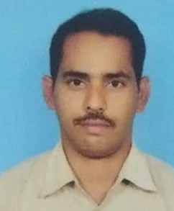

Department: Electronics and Communication Engineering
College: Gudlavalleru Engineering College
Mobile: 8143786004
E-Mail:khadeer786m@gmail.com
----------------------------------------------------------------------------------------------------
Address for Communication
D.no: 1/200-1A, Nizam peat, Bypass Road, opposite Boys Hostel, Gudivada-521301, Krishna Dt., Andhra Pradesh.
Academic Qualifications
S. No | Name of the Degree  (Starting from Higher Degree to 10th Class) | University | Percentage of Marks/Grade | Specialization | Year of Pass
1 | B.A | Nagarjuna University, Guntur. | First Class | -- | 2017
2 | SSC | State Board of Secondary Education | 47% | -- | 2012

Professional Experience
S. No | Designation | Institution Name | Working Period
S. No | Designation | Institution Name | From | To
1 | Skilled Assistant | SR Gudlavalleru Engineering College, Gudlavalleru | 1/11/2024 | Till Date
2 | Lab technician | V.K.R, V.N.B & A.G.K college of Engineering, Gudivada. | 08/01/2015 | 01/05/2020
3 | Lab technician | V.K.R, V.N.B  polytechnic college, Gudivada. | 01/05/2020 | 30/06/2024

Workshops Organized No.: NIL

Workshops /Conferences /Seminars Attended No.: NIL

Certification courses attended: 02
- Diploma in Computer Application
- Hardware & Networking

College Level:
- Assistance in CC camera networking at college level.

Declaration
I hereby declare that all the above-furnished information is correct to the best of my knowledge.

Date: Signature
Place: (ABDUL KHADIR)

